S1 Base Station Frame Design Guide

# Overview

The frame is the interface between four separate components.

* the S1 quadrocopter (located on top of the frame / embraced by the frame)
* the charging station PCB (located beneath the frame)
* the charging station battery (located beneath the quadrocopter and charging station PCB)
* the outer case

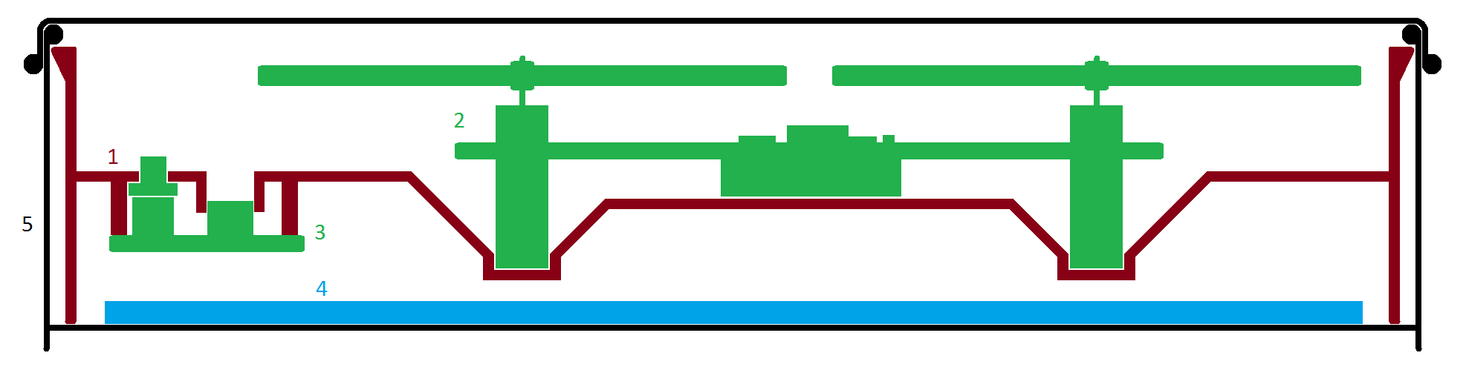

Sketch (side view) of the frame (1), quadrocopter (2), charging station PCB (3), charging station battery (4) and the case (5) – note that this sketch does not properly represent the relative sizes of the components (e.g. the charging PCB is much larger and will therefore reach far into the domain of the quadrocopter)

The strength of the frame shall be 1mm (uniformly).

The frame will be produced by joining two metal molds and filling them with two liquid plastic components. This means that no overhanging features on either side are allowed.

The overall appearance of the frame can be chosen at free will, as can any attributes that are not constrained by any of the four components.

3D CAD files of the quadrocopter and the charger PCB are available. Please contact the electrical engineering department for details.

# Quadrocopter

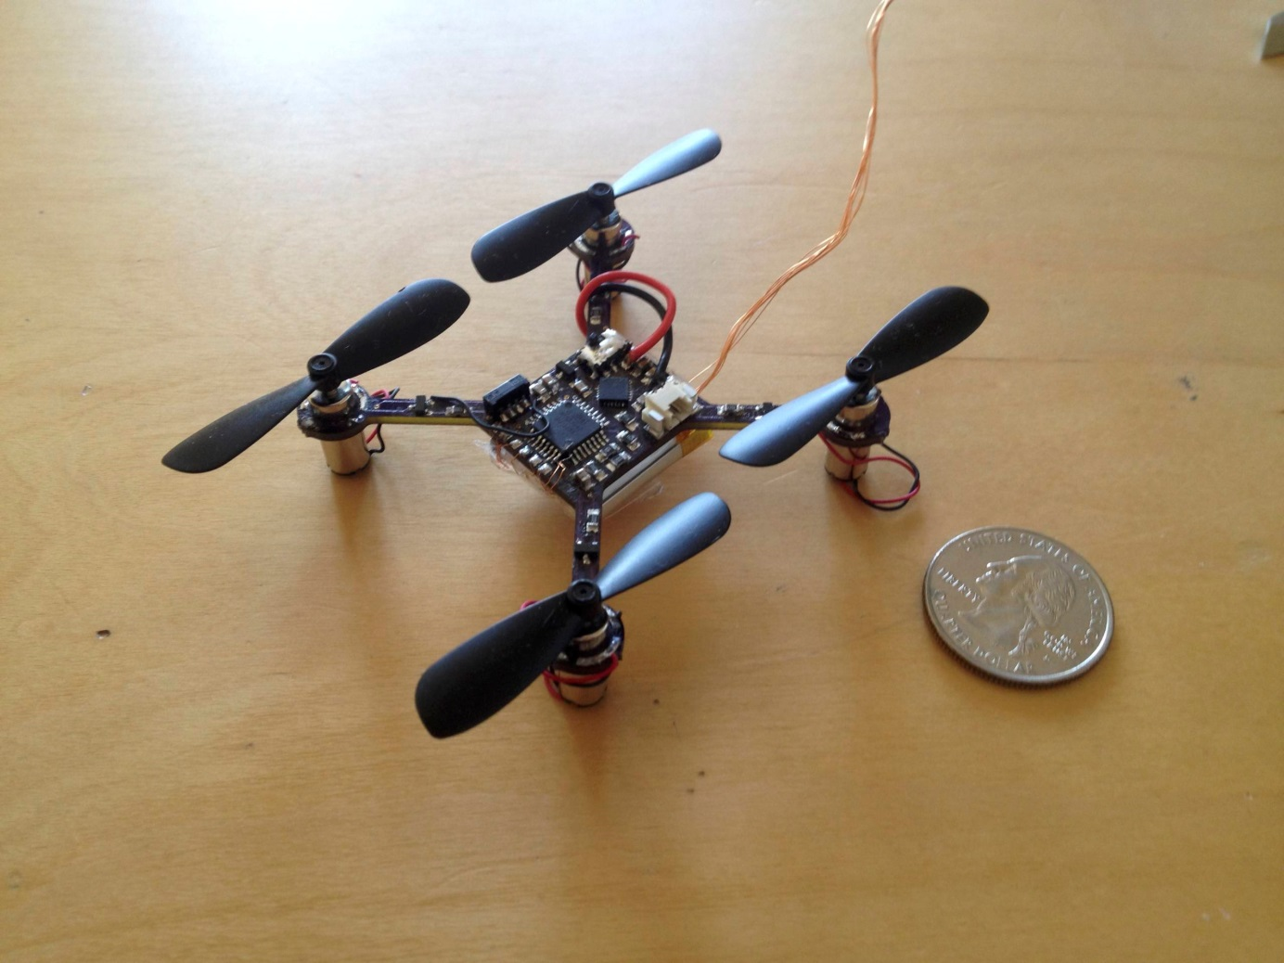

S1 Prototype – the physical shape of the release version will remain the same

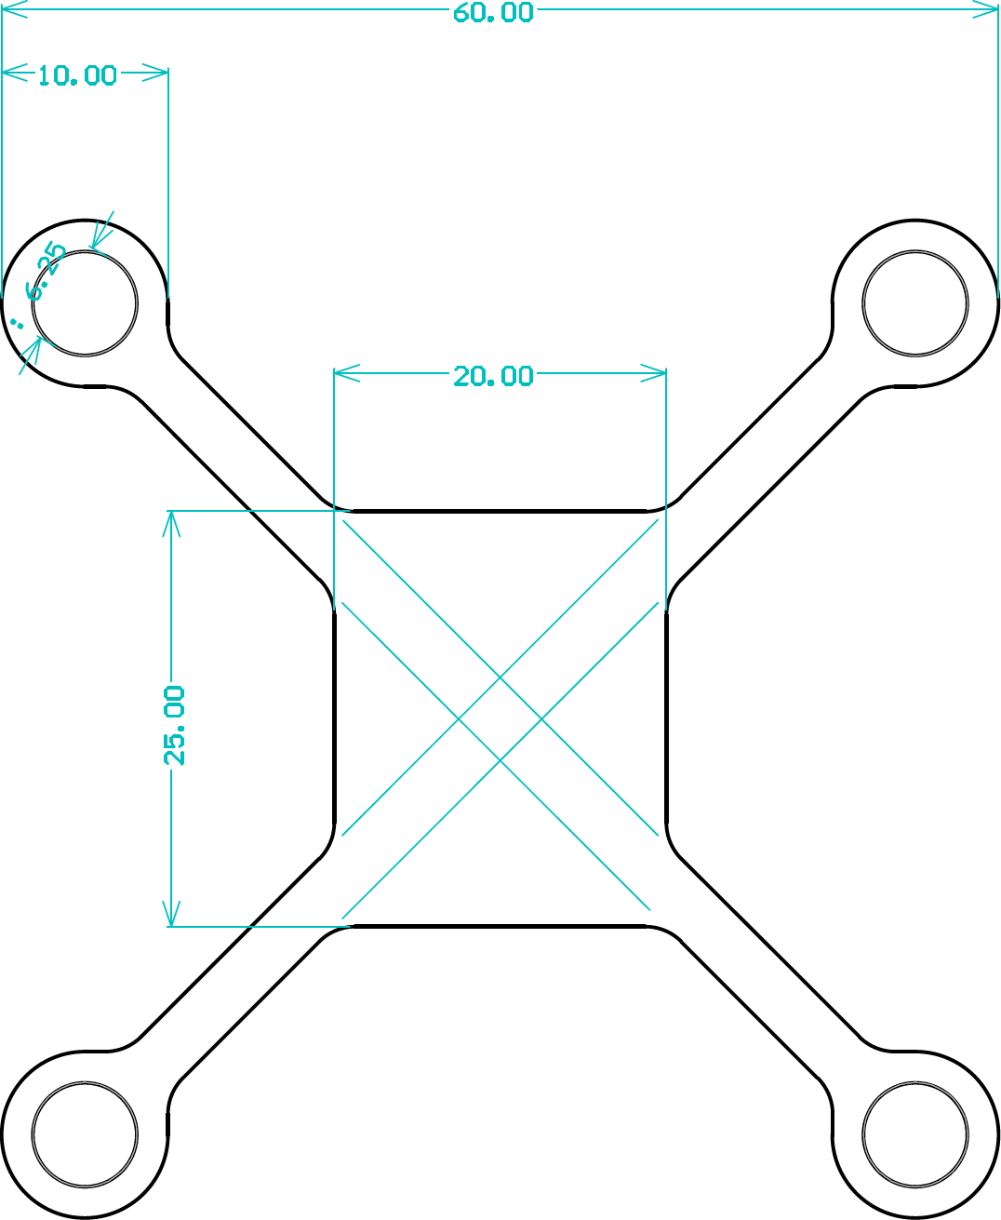

Outline of the quadrocopter PCB (all dimensions in mm)

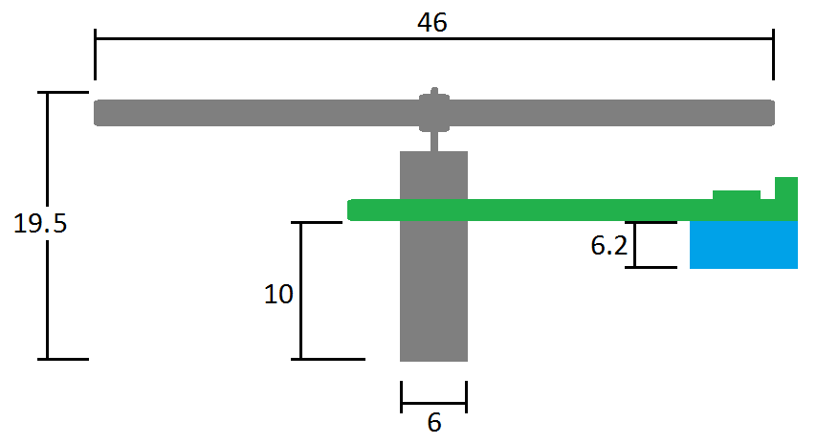

Sketch (side/front view) of one quadrocopter arm (all dimensions in mm) – the propellers can be assumed not to be wider than 10mm

The frame profile should be designed such that it touches the belly (the battery) of the quadrocopter. In this area the plastic strength should be decreased to 0.5mm in order to enable future extensions related to wireless charging.

A means has to be found to hold the quadrocopter in place for transport. A possible solution is to stretch a rubber band between two hooks drilled into the frame on either side of the quadrocopter.

# Charging Station PCB

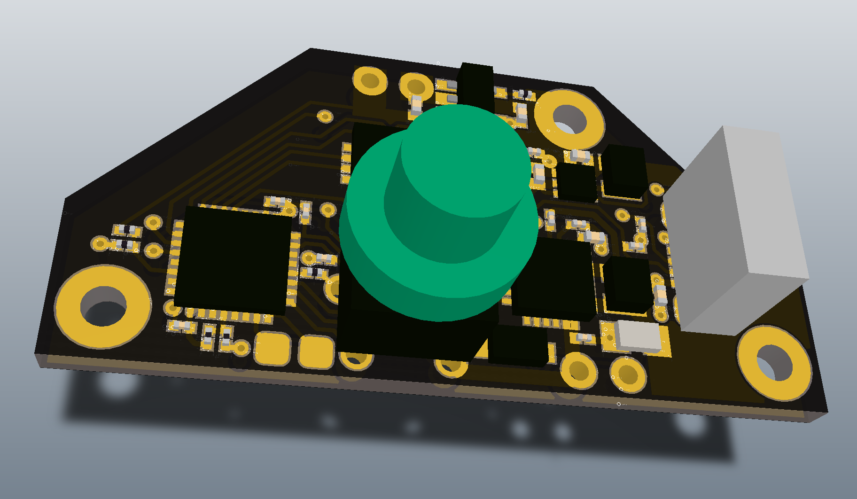

Preliminary 3D render of the charger PCB

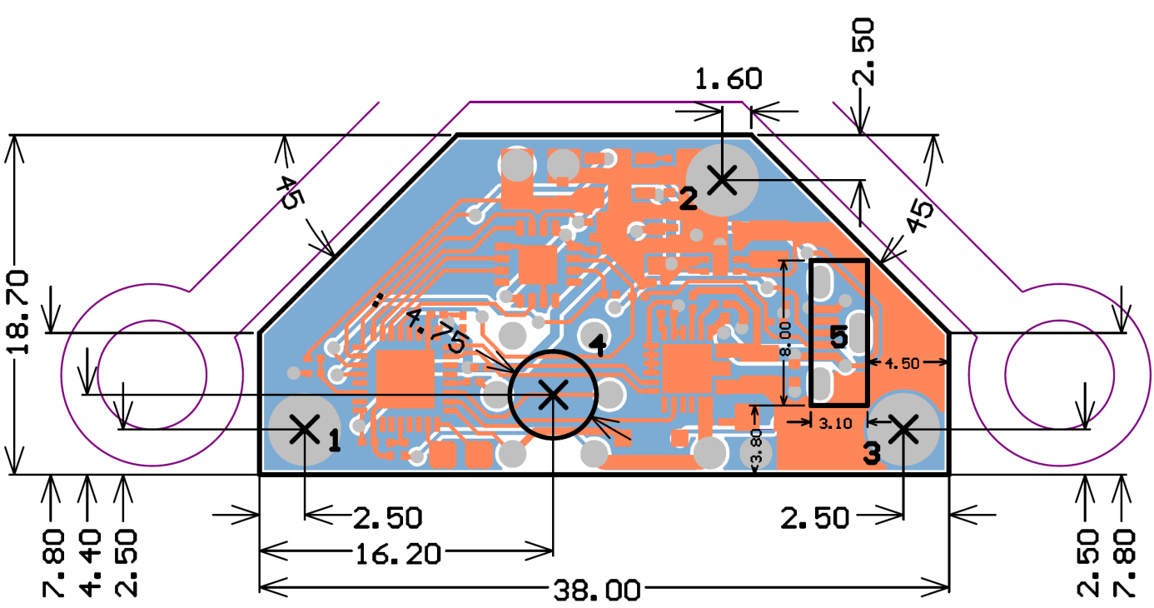

Top view of the charger PCB showing the positions of the screw holes (1-3), the power button (4) and the USB receptacle (5) (all dimensions in mm, angles in degrees)

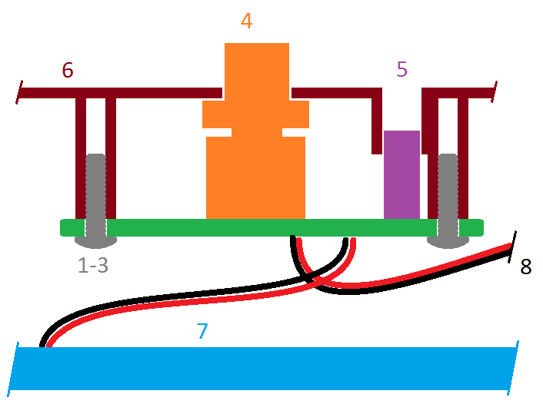

Front view of the charger PCB mounted to the frame (1-3: screws, 4: power button, 5: USB receptacle, 6: frame, 7: battery, 8: quadrocopter charging cable)

The frame will act as the front panel of the charger and as such shall incorporate a circular cutout for the power button (4) and a rectangular one for the vertically mounted Micro USB receptacle (5). The USB receptacle does not reach up to the frame so a channel-like structure could be considered to embrace the receptacle. Such a structure must not extend down for more than 4mm. The PCB is mounted to the frame using three M2 screws (1, 2 and 3). A 1.8mm drill hole is proposed. The diameter of the screw mounts shall not exceed 4mm. The gap between the PCB and the frame shall be 8mm. The PCB thickness is expected to be 1.6mm. The clearance beneath the PCB must be 7mm or greater to leave room for the battery connector.

A 3mm hole for the device charging cable must be placed somewhere in the frame. The location of this hole can be chosen freely as the harness is long enough.

# Charging Station Battery

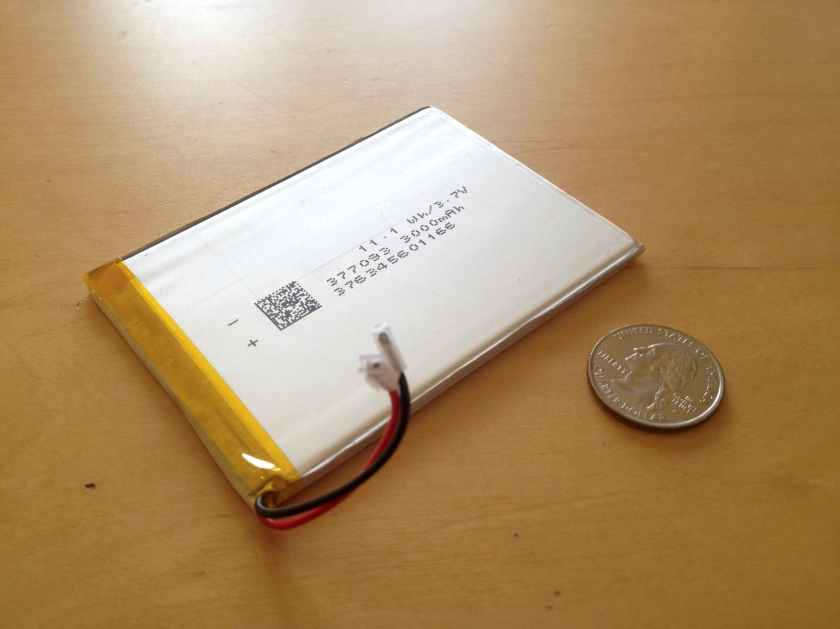

The charging station battery

The battery is the lowest component in the device and is attached directly to the bottom of the case using double sided tape. Its nominal dimensions are: 3.7*70*93mm. The frame shall not touch the battery but rather stand on a margin that is aligned with the border of the case.

# Outer Case

The case consists of a rectangular tin box with rounded edges. We are still looking for an adequate supplier, so the dimensions are not yet exactly known and should therefore be parameterized. For reference please use the inner dimensions 102mm*68mm*26mm with a corner radius of 10mm.

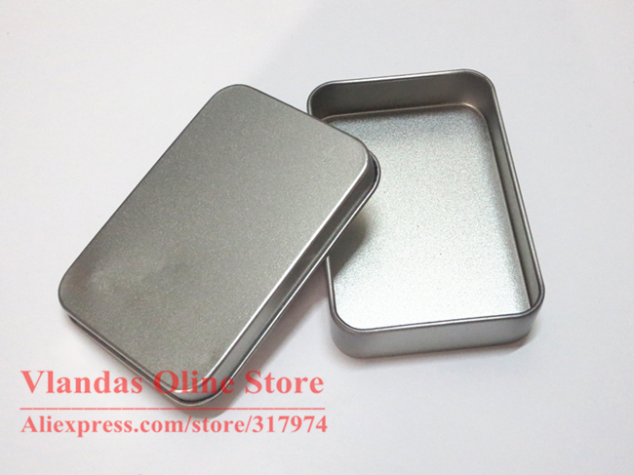

Tin box to be used as case

The upper edge of the case border extends slightly inwards. This leaves the opportunity for incorporating a clip that holds the frame in place. The preferred locations for such clips are the four corners.

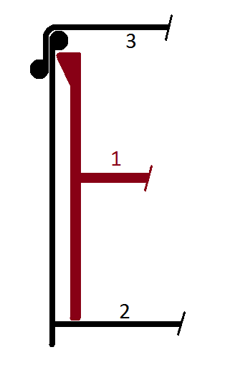

*Sketch of the clip showing the frame (1), the tin box (2) and the lid (3)*

consider the environment before printing this document